**Task 04**

**Simple Keylogger**

**Create a basic keylogger program that records and logs keystrokes. Focus on logging the keys pressed and saving them into a file.**

## ****✅ Introduction****

A **keylogger** is a software program designed to **monitor and log keystrokes** made on a keyboard. These tools can be used for **authorized purposes** such as parental control, accessibility testing, or studying user behavior. However, **unauthorized use** is a **serious breach of privacy and may be illegal**.

This project involves building a **basic keylogger using Python** for **educational purposes only**, with an emphasis on understanding how key events are captured at the software level.

## ⚙️ Working of the Keylogger Tool

The tool performs the following steps:

1. **Starts a background listener** using the pynput library.
2. **Captures every keypress** and logs it to a local file.
3. **Handles special keys** (e.g., Enter, Space, Ctrl) by logging them in a readable format.
4. Allows termination by pressing a **specific key** (e.g., Esc).
5. Stores the captured keystrokes in a log file for review.

## 🧠 Python Code (Keylogger)

Install the required library: (in cmd prompt)

pip install pynput

**Implementation of code in Python**

**Steps: -**

1. Choose a code editor or IDE as per your choice.
2. Install and set up **VS code.**

Download: Visit <https://code.visualstudio.com/> and install VS Code.

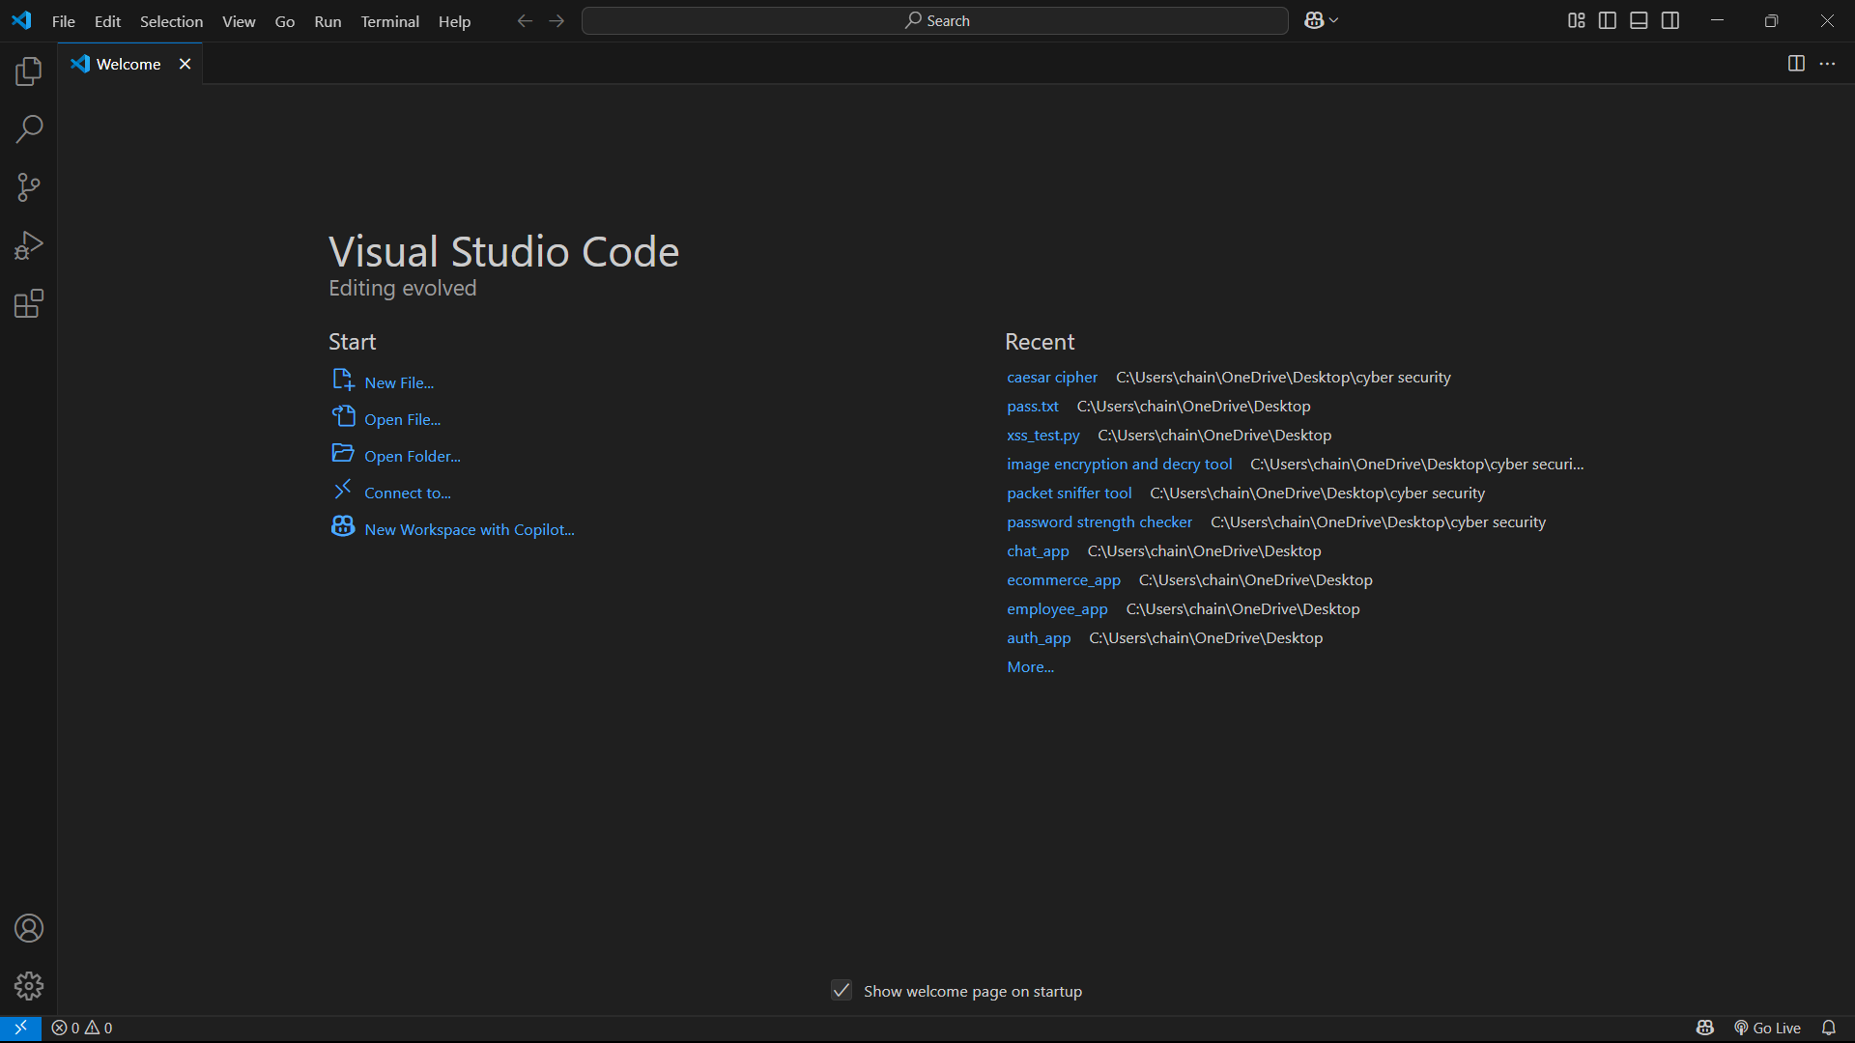

Go to extension tab (ctrl+ shift+ x) and search for Python. Click install on the official Microsoft Python extension.

Choose python interpreter (I have selected Python 3.12.7)

1. Create and save a python file (file having extension .py)

In VS Code: File : New File.

And, Save the file extension .py

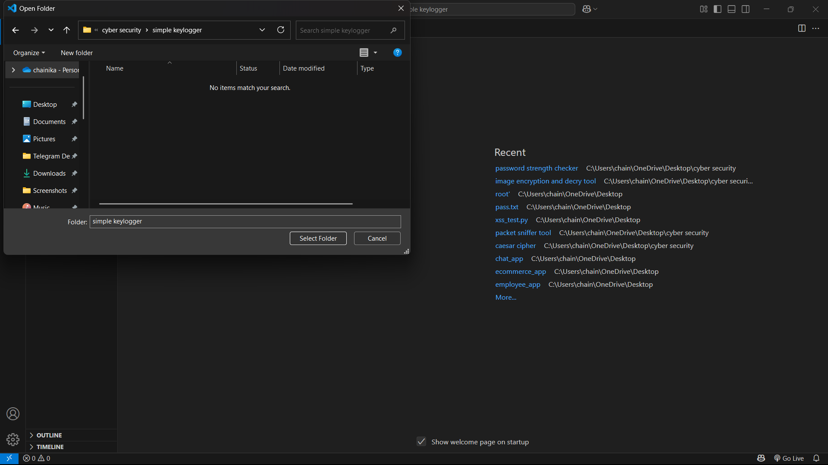

1. Initiate with writing your program:

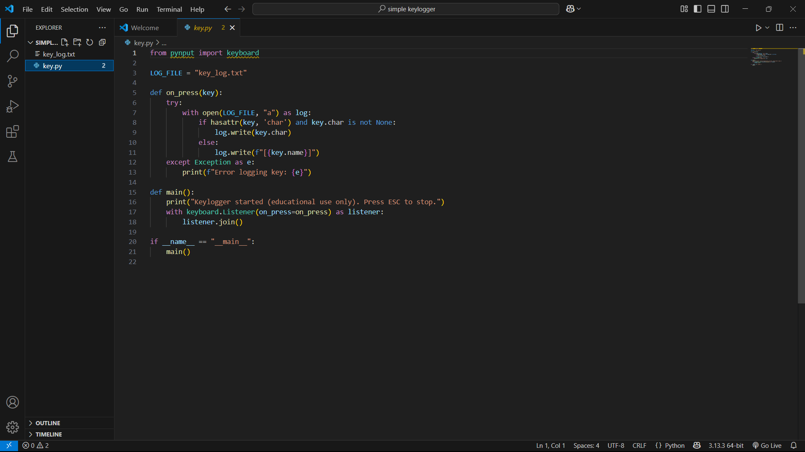

1. Then Run the program in the terminal:

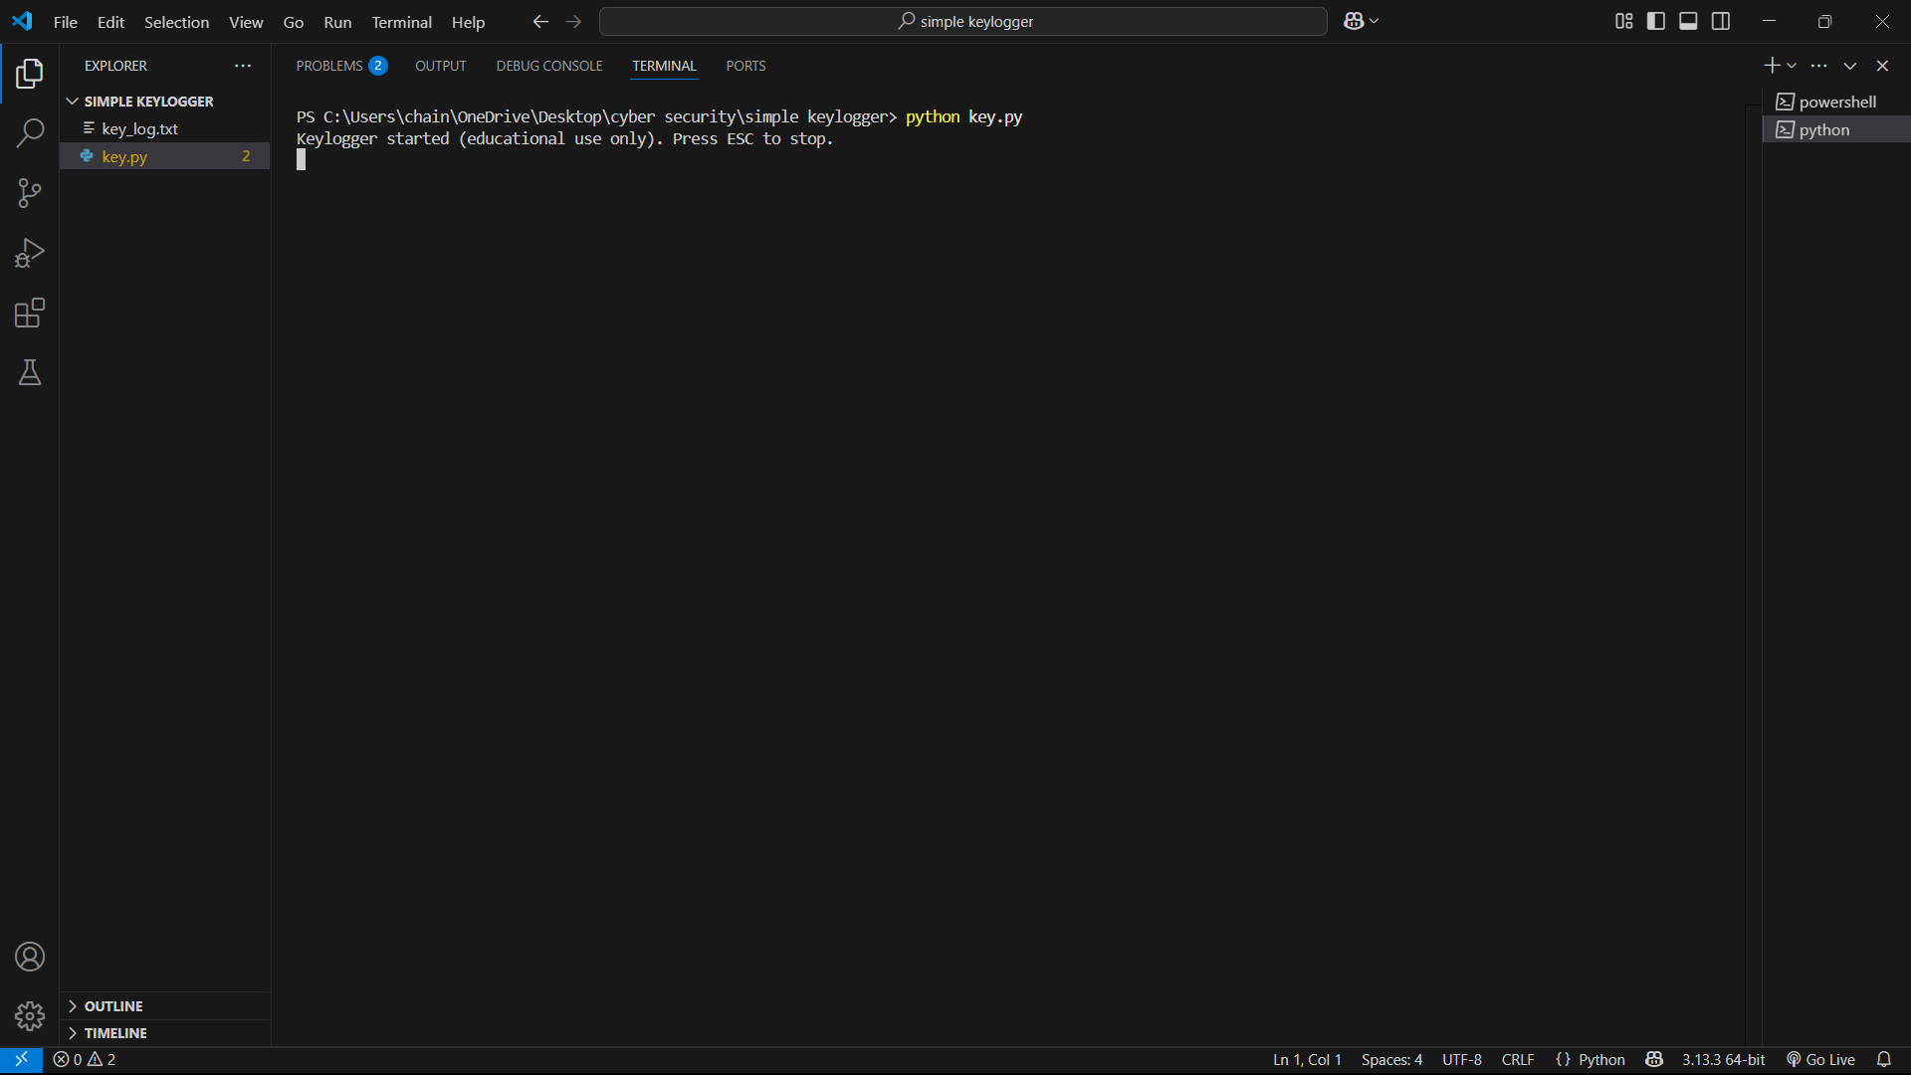

6. After running the code in the terminal :

### 🔍 What This Script Does

* Starts a background listener for keyboard input.
* Logs **regular keys** (e.g., a, 1, @) as-is.
* Logs **special keys** (e.g., space, enter, ctrl) as [keyname].
* Saves all logs to key_log.txt in the current directory.
* **Stops on pressing** Esc (you can customize this behavior).

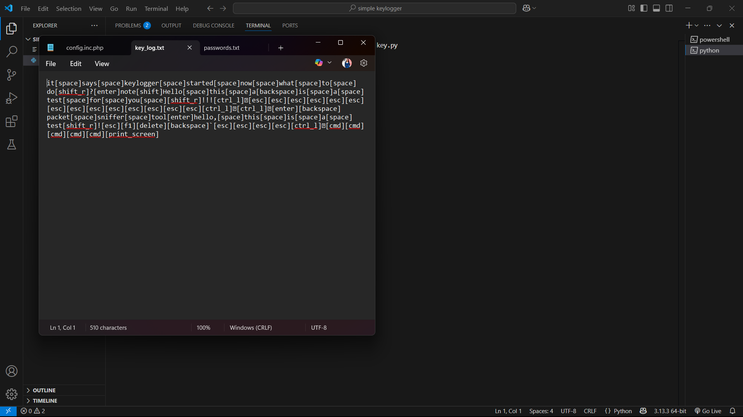Successful running of program with the result shows the correct program.

## ****🔐 Ethical and Legal Considerations****

* **Informed Consent**: Keyloggers **must only be used with explicit permission**.
* **Legal Compliance**: Unauthorized use can violate laws like the **Computer Fraud and Abuse Act (CFAA)** or **Data Protection Regulations**.
* **Use Case Limitations**:
  + ✅ Parental control (with consent)
  + ✅ Accessibility testing
  + ✅ User behavior research (authorized)
  + ❌ Unauthorized spying or data theft (illegal)

## 🎯 Significance of the Tool

* 📚 **Educational Value**: Helps understand OS-level input capture and event listeners in Python.
* 🔍 **Debugging Input Issues**: Useful in accessibility or usability testing.
* 🧪 **Security Awareness**: Demonstrates how easily keystrokes can be captured, stressing the need for secure input handling and privacy protections.

## ✅ Conclusion

This basic keylogger tool demonstrates how Python can be used to monitor keystrokes using simple libraries like pynput. While powerful, this capability must be used **responsibly**, ethically, and in accordance with **applicable laws**. This project is ideal for learning **input event handling**, **file operations**, and the **ethical use of security tools**.

**Presented by: - Chainika Dongre Date: - 18 May 2025**